**Nintendo**

Game Design Document for:

**TETRIS**

“Life is like Tetris; if it doesn't fit, just flip it over”

All work Copyright 2018 by Dragon Corp

Written by Ace Dragonair

Game Boy Version #1.96

Monday, October 29, 1898

**Table of Contents**

**NAME OF GAME**_________________________________1

**DESIGN HISTORY**_______________________________ 3

Version ____________________________________ 3

**GAME OVERVIEW**_______________________________ 4

Main focus ___________________________________4

Movements___________________________________4

Win Condition ________________________________ 4

World Rendering ______________________________ 4

**Game Character** _________________________________ 5

Character Rendering ____________________________ 5

**Game Engine** ____________________________________6

Randomizer __________________________________ 6

Level _______________________________________6

Speed ______________________________________ 6

Scoring _____________________________________ 6

Difficulty ____________________________________ 7

Two-Player ___________________________________7

**User Interface** ___________________________________8

Score, Level, Lines, Tetriminos Display________________ 8

**Musical Scores and Sound Effects**____________________9

**Single-Player Game**____________________________________________10

Player experience, Gameplay Time___________________________ 11

**Monetization _____________________________**11

**Design History**

Tetris was created by Alexey Pajitnov in June 1984. Alexey Pajitnov was an artificial intelligence researcher working for the Soviet Academy of Sciences at Moscow Computer Center.

The game was inspired around the game pentominoes but instead of twelve different shapes variation it was change to tetrominoes which is instead a seven shape variations.

Version 1

This version results made the screen fill up quickly. Realizing this Pajitnov deleted the lines, thus creating part of the Tetris Gameplay.

**Game Overview**

Main focus

Tetris is an infinite point base system game. The way to score points in Tetris is by creating horizontal lines by manipulating the random pieces given by the matrix.

Movements

The pieces falls from the top, where one can move them horizontally, spin them to line up evenly at the bottom of the matrix.

Win Condition

Tetris does not have a win condition, it only have a loose condition. A player looses the game of Tetris when they can no longer keep up with the increasing speed, which in turn causes the stack shapes to stack up to the top of the playing field. Another way is when the player can not find an appropriate solution to the shapes they where given thus making it difficult to form lines. This is called “topping out.”

**Game World**

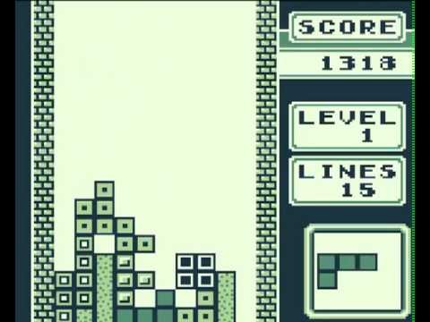

**The Physical layout**

Scale

The world is ten wide and eighteen in height.

Travel

The shape moves from top to bottom

**World Rendering**

It is rendered in 3D.

**Game Characters**

Tetriminos are geometric shapes composed of four square blocks each.

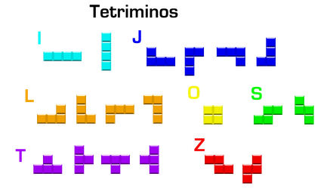

Composed of I, J, L, O, S, T, Z

**Character Rendering**

It is rendered in 2D

**Game Engine**

Tetrimino randomizer

L: 10.7 % J, I, Z: 13.7 % O, S, T: 16.1 %

Levels

Increased every 10 line cleared

Game Boy runs at 59.73 frames per second

Speed levels

|  |  |
| --- | --- |
| **Level** | **Frames per row** |
| 0 | 53 |
| 1 | 49 |
| 2 | 45 |
| 3 | 41 |
| 4 | 37 |
| 5 | 33 |
| 6 | 28 |
| 7 | 22 |
| 8 | 17 |
| 9 | 11 |
| 10 | 10 |
| 11 | 9 |
| 12 | 8 |
| 13 | 7 |
| 14 | 6 |
| 15 | 6 |
| 16 | 5 |
| 17 | 5 |
| 18 | 4 |
| 19 | 4 |
| 20 | 3 |

Scoring

Points are awarded based on the current level and number of lines cleared.

The maximum score is 999999.

Difficulty

Player can select a starting level or choose to pre-fill an area with given randomly placed blocks.

Two player mode

The two consoles are connected via the Game Link Cable. The objective is to remain in the play for longer than the opponent. A player can score a Double, Triple, or Tetris to add an additional row in the opponent stack.

**User Interface**

Score

Located on the top left corner. It keeps track of the player’s points.

Level

Located below the score board. It keeps track of the player’s level

Lines

Located below the players level. It keeps track of the amount of lines the player created.

Tetriminos Display

Displays the next tetrimino to appear in the matrix.

**Musical Scores and Sound Effects**

Soundtrack composed by game musician [Wally Beben](https://en.wikipedia.org/w/index.php?title=Wally_Beben&action=edit&redlink=1).

Music A is an instrumental arrangement of a Russian folk tune called "Korobeiniki"

Music B is an original track by Hirokazu Tanaka,

Music C is an arrangement of Johann Sebastian Bach's French Suite No. 3 in B Minor, BWV 814, IV. Menuett – Trio.

**Single-Player Game**

Player experience

Tetris is a highly addictive game that has a slow start but gradually becomes exiting as the speed increase and the player is force to react quickly to the shapes.

Gameplay Time

Tetris is a short game that last for a few minutes depending on whether the players skills.

**Monetization**

Allow you to compete with your friends in a new interactive method on this Game Boy.

Experience an intense fast pace organization game.